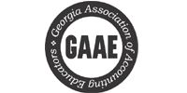 | 2017 Newsletter and 2018 Conference Save the Date: February 9-10, 2018
October 9, 2017 | Volume 2, Number 1
“Make sure you have the (February 9th and 10th 2018) meeting on your mind and in your calendars.”  Make your 2018 plans. Information on registration, hotel accommodations, etc. coming soon. Visit our website: GAAE. org  Our annual conference would not be possible without the financial support of our many sponsors. | Staying in touch with our Accounting educators  It is hard to believe that the summer is nearly over. Whether you have spent your summer researching, teaching, or relaxing we hope that you have been able to take some time off to recharge, refresh, and reboot and enjoy your time away from the demands of committee work, faculty meetings, and full teaching loads. By all measures our 2017 Annual Meeting was a success. However, we have used your survey to help us plan for our 2018 meeting. We are grateful for all our 2017 sponsors and have highlighted each of the organizations below.  2018 Annual Meeting Dates and Highlights  We look forward to hosting the 2108 Annual meeting February 9th and 10th, 2018 the Kennesaw State University Conference Center.  We are excited to announce that our Friday Keynote Speaker will be Denise Schmandt-Besserat, a French-American archaeologist and retired professor of art and archaeology of the ancient Near East. She spent much of her professional career as a professor at the University of Texas. Denise has been widely reported in the public media and television, such as Discovery, ABC, etc. She will speak about the history of writing and notes that accounting was a precursor to writing. Denise has published several books and articles on the subject.  Additionally, we look forward to a variety of presentations from you, our members. Please check your email for “The call for proposals” in early October. It is not too early to think about a presentation topic. We hope to receive a wide range of proposal topics that will be of interest to our diverse membership.  2017 Sponsors Highlights  The Educational Foundation of The Georgia Society of CPAs and The Georgia Society of CPAs are dedicated partners of GAAE. Our organization would not be able to continue operations without their generous support.  The Educational Foundation of the Georgia Society of CPAs provides:  - Keynote Sponsorship funding of the Annual Conference  - Speakers for the annual conference  - Student scholarships - In 2016 over $ 92,000 were awarded to 35 students.  - Funding for programs to increase awareness of the accounting profession on college campuses.  - Recognition of outstanding accounting educators through the “Outstanding Educator Award.”  The Georgia Society of CPAs provides:  - Sponsorship and hosting of GAAE’s website  - Significant staff support for related programming  - Registration and other Administrative support  - Reduced membership fees for educators and students  To learn more about the mission of The Educational Foundation and the wide variety of programs it offers to accounting students and faculty, please visit foundation.gscpa.org.  To learn more about The Georgia Society and how it works to promote and protect the accounting profession in Georgia, please visit www.gscpa.org.  If you have any questions or need further information, please don’t hesitate to email Callie Hammond, manager, foundation & student initiatives for GSCPA at [chammond@gscpa.org]chammond@gscpa.org or by calling 800-330-8889, extension 2956.  Ramsey Solutions  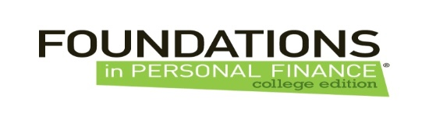  Foundations in Personal Finance engages students and teaches them practical, relevant financial skills. The design is to accommodate the variety of implementation strategies colleges and universities may use to incorporate the curriculum into the classroom. The program is completely turn-key for educatiors through both print and online delivery options.  Our message is different. We’re not a financial institution, we simply challenge the way they view money and empower them with the education they need to graduate on a solid financial foundation. These students are our future. Let’s invest in them.  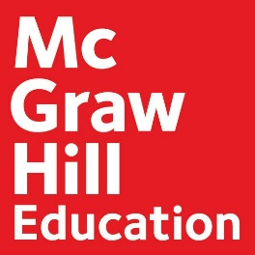  Connect Accounting helps students learn more efficiently by providing feedback and practice material when they need it, where they need it. Connect’s assignable, gradable end-of-chapter content helps students learn to apply the concepts in accounting and, in more comprehensive material, analyze their work to form business decisions. Connect’s robust accounting software allows for flexibility in learning styles and provides opportunities for courses to be delivered in traditional, online, and blended settings.  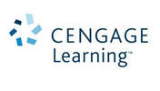  Cengage Learning is a leading educational content, technology, and services company for the higher education and K-12, professional and library markets worldwide. The company provides superior content, personalized services and course-driven digital solutions that accelerate student engagement and transform the learning experience. Cengage Learning is headquartered in Boston, MA with an office hub located in San Francisco, CA. Cengage Learning employees reside in nearly 40 different countries with company sales in more than 125 countries around the world. For more information, go to: www.cengage.com.  Core Businesses  Wiley's Global Research business is a provider of content-enabled solutions to improve outcomes in research, education and professional practice with online tools, journals, books, databases, reference works and laboratory protocols. Wiley's Professional Development business creates products and services that help customers become more effective in the workplace and achieve career success. It brings to life the ideas and best practices of thought leaders in business, finance, accounting, workplace learning, management, leadership, technology, behavioral health, engineering/architecture, and education to serve these communities worldwide. Wiley Global Education serves undergraduate, graduate, and advanced placement students, lifelong learners. We publish educational materials in all media, notably through WileyPLUS, our integrated online suite of teaching and learning resources.  Roger CPA Review’s learning system is designed with this important philosophy in mind: The key to any success is enjoying what you do. We take special care to ensure your study process is Efficient, Effective, and - most importantly - Enjoyable, so that you can successfully and seamlessly attain your goal of becoming a CPA.  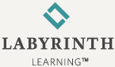  Today, more than two million students have learned the Labyrinth way in community colleges (including credit programs), corporate training, continuing and community education, career and technical education, high schools and other programs. Books are just the beginning, however. They form the core of Labyrinth Learning’s solutions — expansive offerings that also include instructor support materials, integrated learning management tools, and eLearning components. These solutions cover a wide variety of subjects from computers and technology to specific disciplines such as accounting.
2017-2018 Officers | President Donald L. Ariail, Kennesaw State University  Vice President Sandria Stephenson, Kennesaw State  Treasurer Bill Black, University of North Georgia  Secretary Joey Sanders, West Georgia Technical College

